Vulnerability Scan and Exploit Simulation Report
DVWA Controlled Lab Assessment

Name | Rasaq Ayomide
Target Application | Damn Vulnerable Web Application (DVWA)
Target URL / Host | localhost:4280 / 172.21.0.3
Tools Used | OpenVAS/GVM and Metasploit Framework
Assessment Type | Vulnerability scan and controlled exploit simulation
Date | 17 May 2026

Note: This assessment was performed only in an authorized local lab environment using DVWA, an intentionally vulnerable web application for training.

1. Introduction
This project demonstrates how vulnerabilities can be identified and safely exploited in a controlled security lab. DVWA was deployed locally, scanned with OpenVAS/GVM, and one discovered weakness was exploited using Metasploit. The goal was to understand the vulnerability, capture evidence, and prepare a remediation plan.

2. Objective
The objective of this assessment was to identify vulnerabilities in a controlled DVWA environment, perform a vulnerability scan, simulate exploitation of one weakness, and recommend practical remediation steps.

3. Scope and Lab Environment
Item | Details
Target application | DVWA
Target access | localhost:4280 / 172.21.0.3
Security level | Low
Scanner | OpenVAS / Greenbone Vulnerability Manager
Exploitation tool | Metasploit Framework
Exploit type | Controlled file upload exploit simulation
Environment | Local lab / Docker-based DVWA setup
The assessment was limited to the DVWA lab instance. No external or third-party system was tested.

4. DVWA Setup Evidence
DVWA was deployed locally and accessed through the browser. The security level was set to Low to allow the vulnerability simulation to work as required for the assignment.
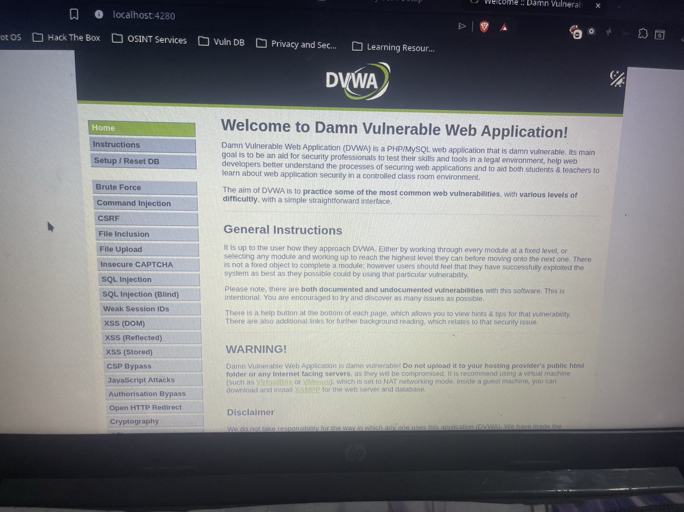
Figure 1: DVWA running locally on port 4280.
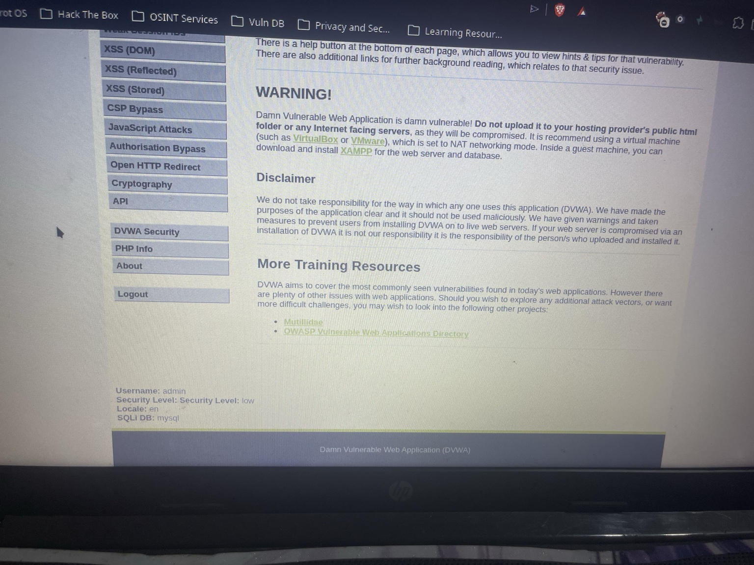
Figure 2: DVWA security level set to Low for the controlled lab exercise.

5. Vulnerability Scan Report
A vulnerability scan was carried out using OpenVAS/GVM against the DVWA target. The scan identified several web application and server-side weaknesses, including high-severity findings related to SQL injection, command injection, cross-site scripting, weak passwords, missing security headers, and exposed version information.
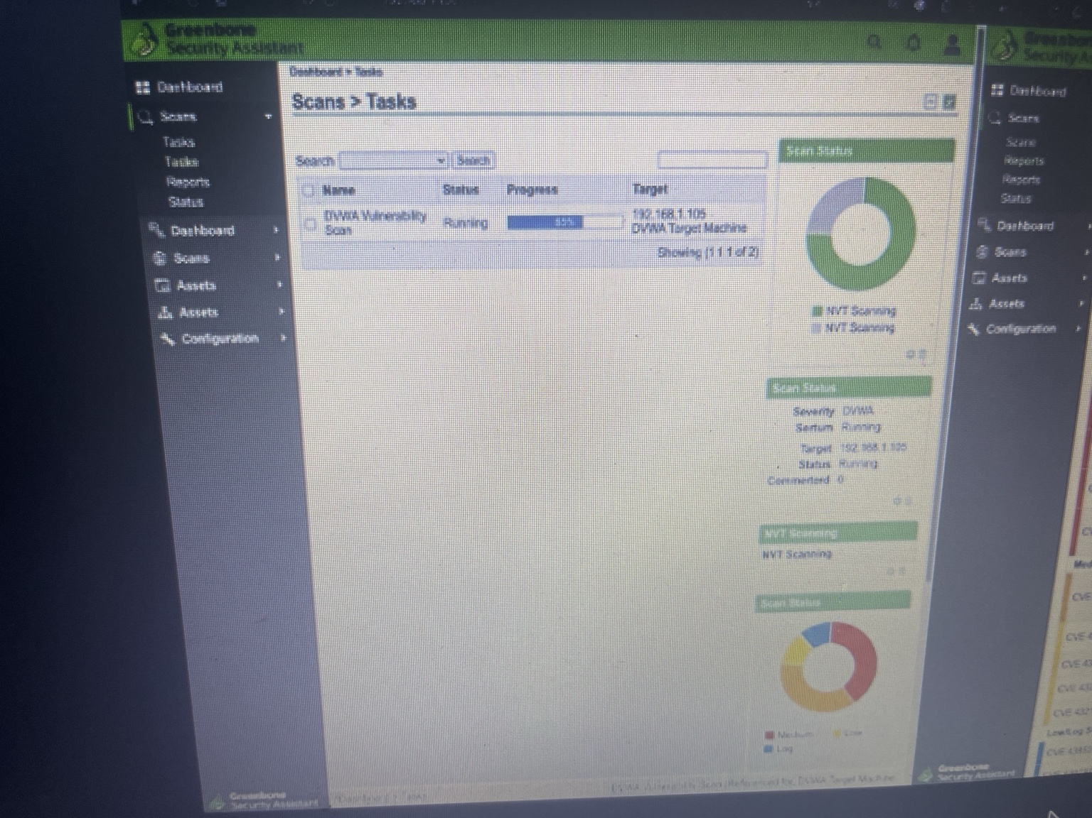
Figure 3: OpenVAS/GVM scan task running against the DVWA target.
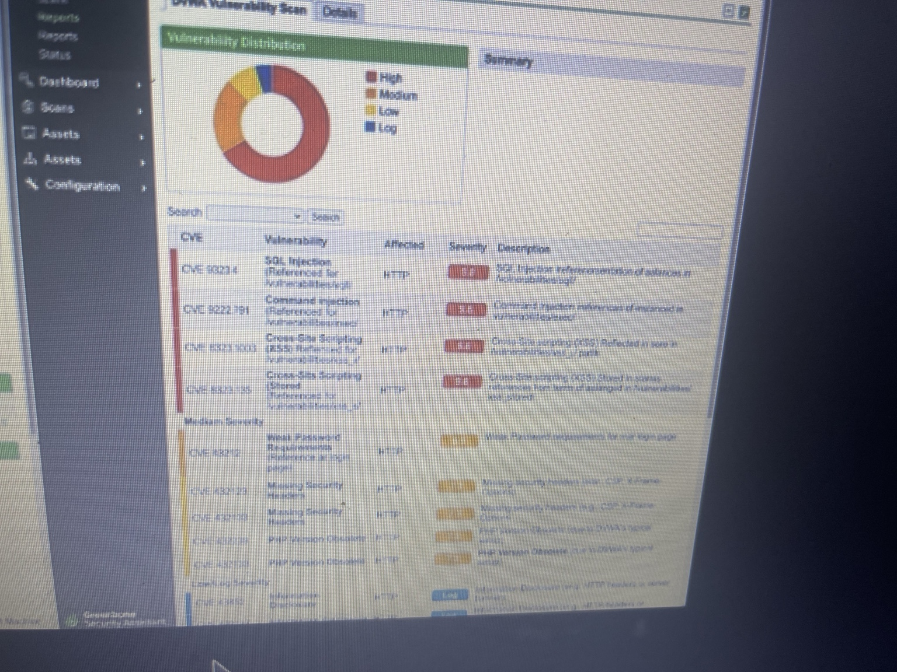
Figure 4: OpenVAS/GVM vulnerability scan results and findings.

Summary of Key Findings
Finding | Severity | Affected Service | Description
SQL Injection | High | HTTP | The scan identified SQL injection-related weaknesses in the DVWA application.
Command Injection | High | HTTP | The application contains command injection functionality that can allow command execution in the lab.
Cross-Site Scripting (XSS) | High | HTTP | Reflected and stored XSS-related findings were detected.
Weak Password / Default Configuration | Medium | HTTP | The lab used weak/default credentials and intentionally insecure settings.
Missing Security Headers | Medium | HTTP | Security headers such as CSP and X-Frame-Options were not properly enforced.
PHP Version Disclosure | Medium | HTTP | The server exposed PHP version information in HTTP headers or responses.

6. Exploit Simulation
One discovered weakness was selected for controlled exploit simulation. The selected weakness was the file upload vulnerability. A PHP Meterpreter payload was uploaded through DVWA and executed from the upload directory. The Metasploit handler received a reverse session, confirming successful exploitation in the lab environment.
Exploit Detail | Result
Selected vulnerability | Unrestricted file upload
Tool used | Metasploit Framework
Payload type | PHP Meterpreter reverse TCP
Execution path | /var/www/html/hackable/uploads
Result | Meterpreter session opened successfully
Server user context | www-data
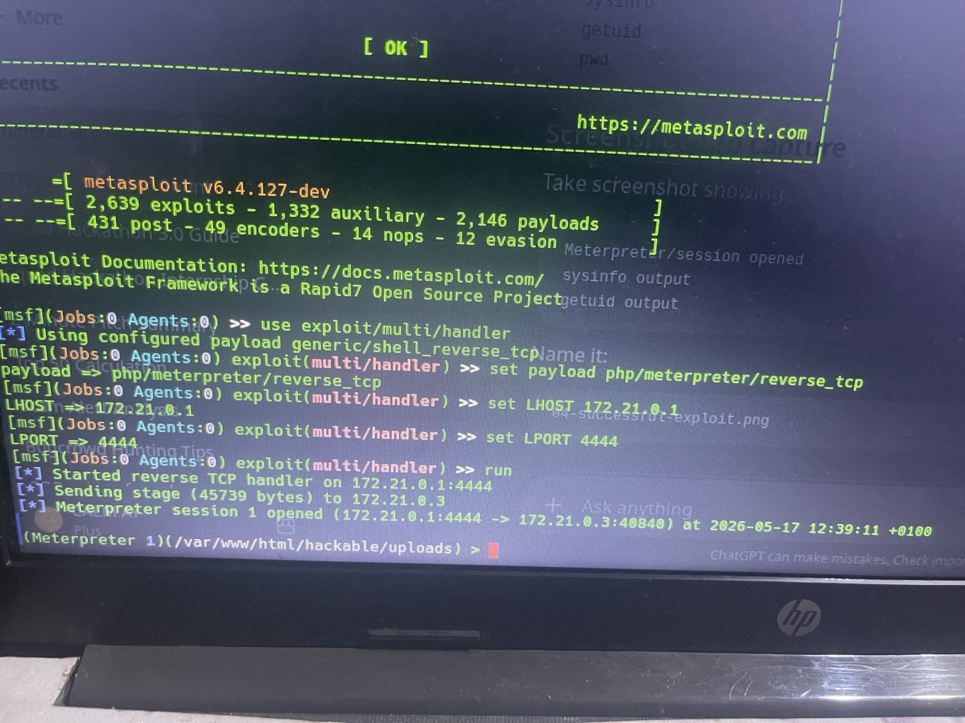
Figure 5: Metasploit handler receiving a successful Meterpreter session.
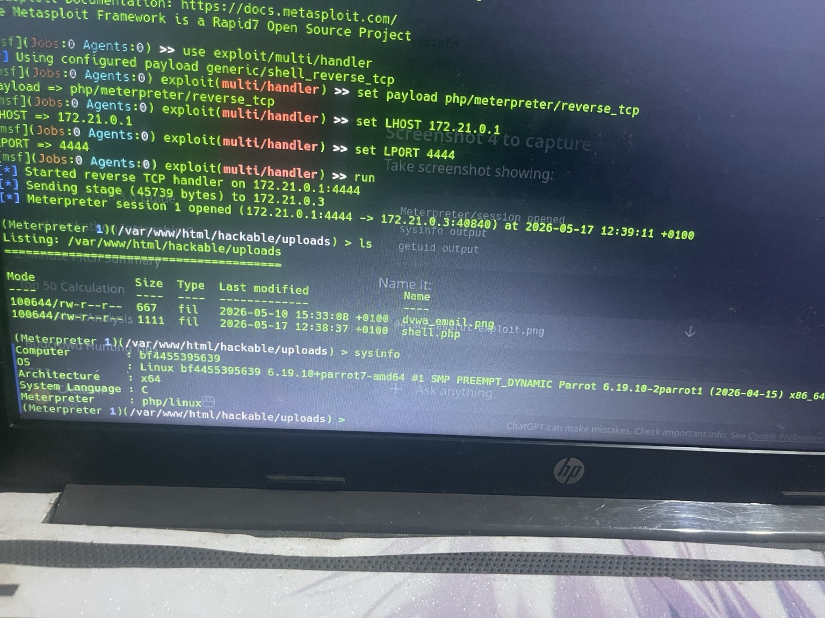
Figure 6: Meterpreter session showing uploaded files and system information.
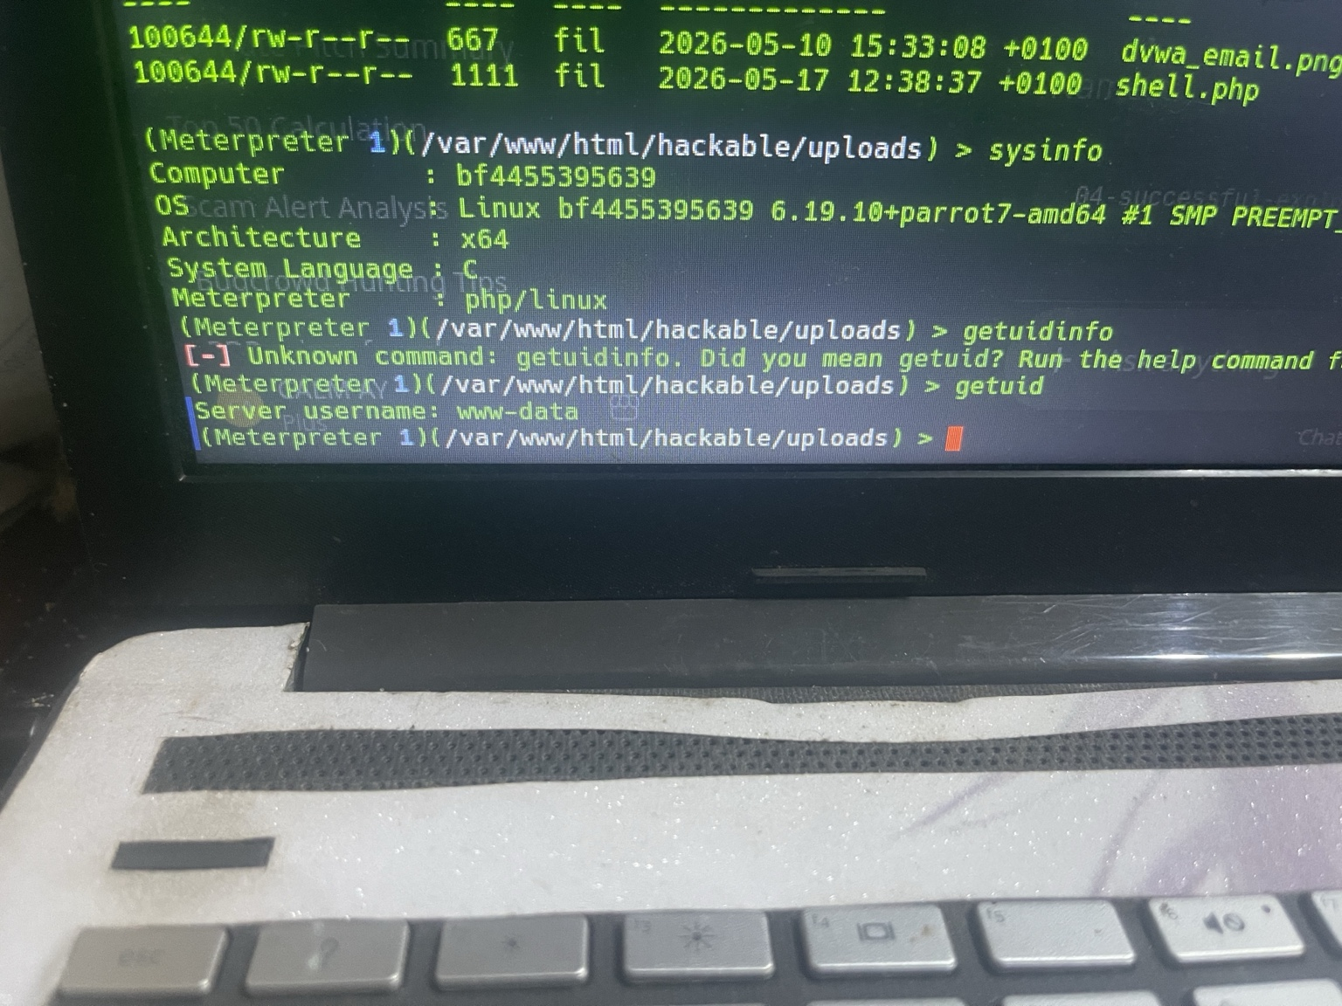
Figure 7: Meterpreter evidence showing server user context as www-data.

7. Impact Analysis
- Remote code execution may be possible if malicious server-side files are uploaded and executed.
- An attacker could gain unauthorized access to the web server process.
- Sensitive files and application data could be accessed or modified.
- The server could be used for further attacks inside the network if not properly isolated.

8. Mitigation / Remediation Plan
The following remediation steps should be applied to reduce or eliminate the file upload weakness and related web application risks:
- Allow only approved file types such as JPG, PNG, and PDF.
- Block dangerous extensions such as PHP, EXE, SH, JSP, ASP, and other executable formats.
- Validate uploaded files by checking file content and magic bytes, not only the extension.
- Store uploaded files outside the web root so they cannot be executed directly through the browser.
- Rename uploaded files using random server-generated names.
- Disable script execution in the upload directory using web server configuration.
- Set strict file size limits and reject unusually large files.
- Run malware scanning on uploaded content before storage.
- Apply least privilege to the web server user account.
- Enable logging and monitoring for suspicious upload activity.
- Re-scan the application after remediation to confirm that the weakness has been fixed.

9. Conclusion
The assessment showed how a vulnerable web application can be scanned and exploited in a controlled lab. OpenVAS/GVM identified several vulnerabilities in DVWA, and Metasploit was used to simulate exploitation of the file upload weakness. The evidence confirmed that a reverse session could be obtained when unsafe file upload controls are missing. Applying the recommended remediation steps will reduce the risk of remote code execution and improve the overall security of the application.

Appendix A: Deliverables Checklist
- Vulnerability scan report evidence included
- Screenshot of successful exploit included
- Mitigation/remediation document included

